Lab-01: Verification of KVL and KCL
Name: Raihan Ahammed ID: 2532600043 Group: 03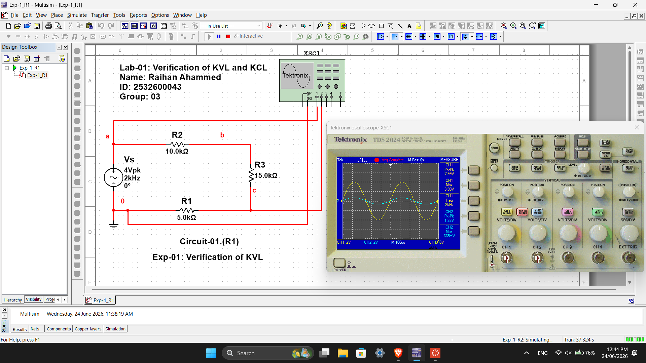
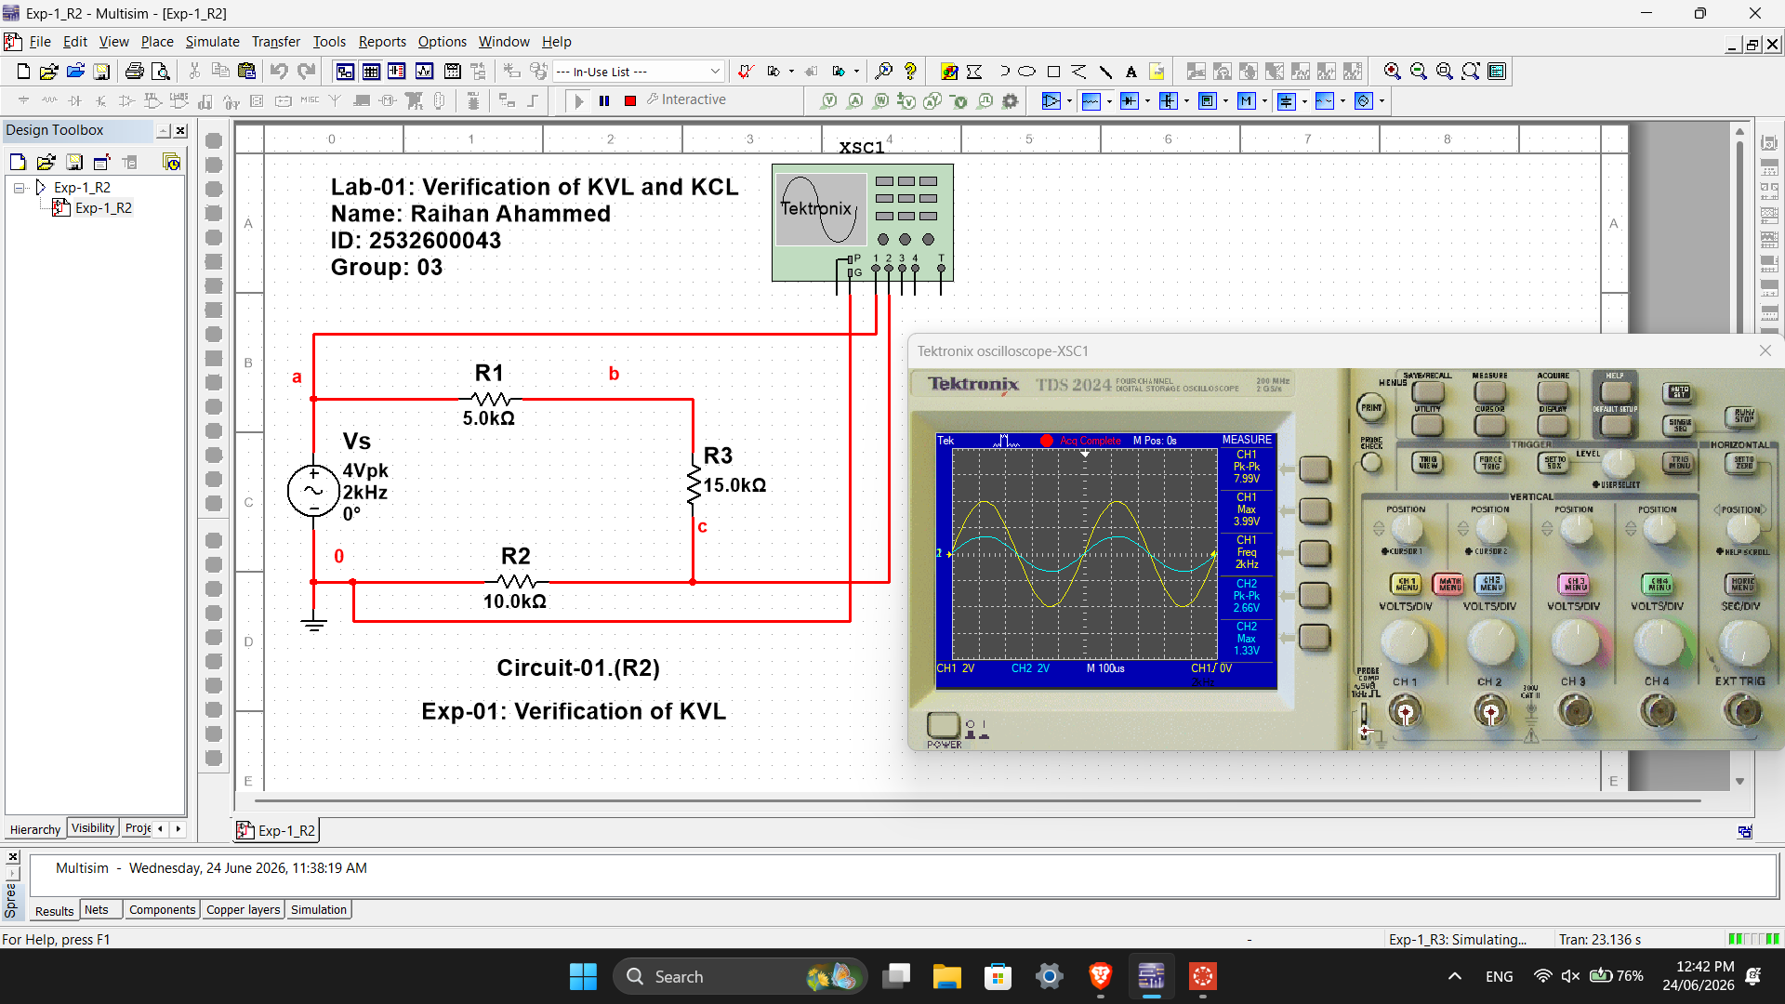
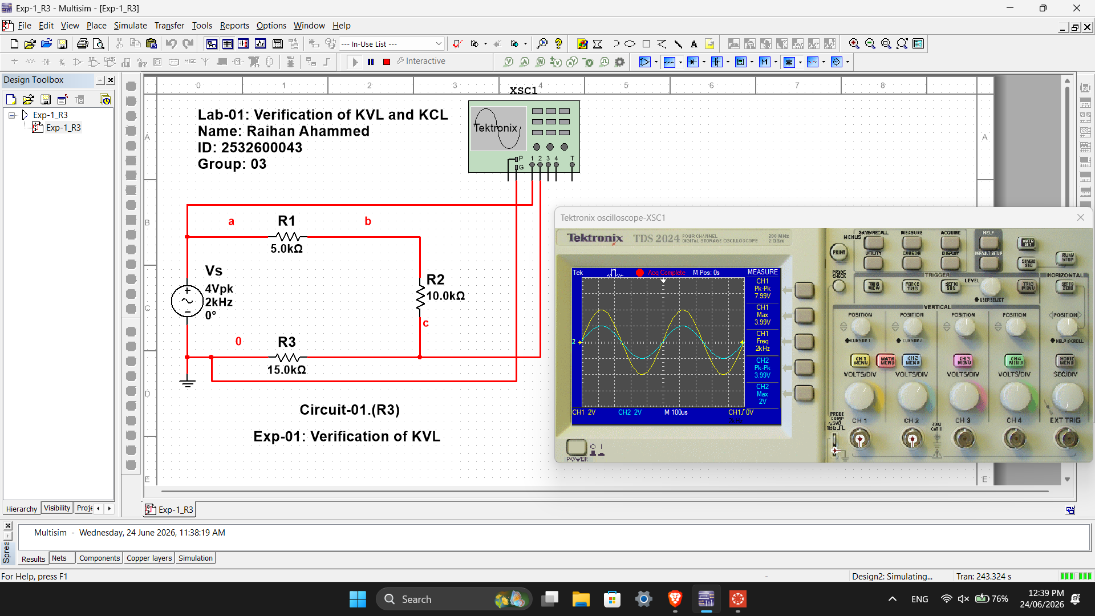

Lab-01: Verification of KVL and KCL
Name: Sarkar Mehedi Hossain Rafi ID: 2533961043 Group: 03
